GUIDANCE FOR THE RAPID RESPONSE
TO AN UNEXPECTED DEATH OF A CHILD AGED 4 TO 17
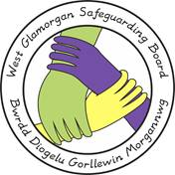

GUIDANCE FOR THE RAPID RESPONSE
TO AN UNEXPECTED DEATH OF A CHILD AGED 4 TO 17

Date Approved: 11th of March 2020
Date for Review: 11th of March 2023
Agreed by West Glamorgan Safeguarding Board
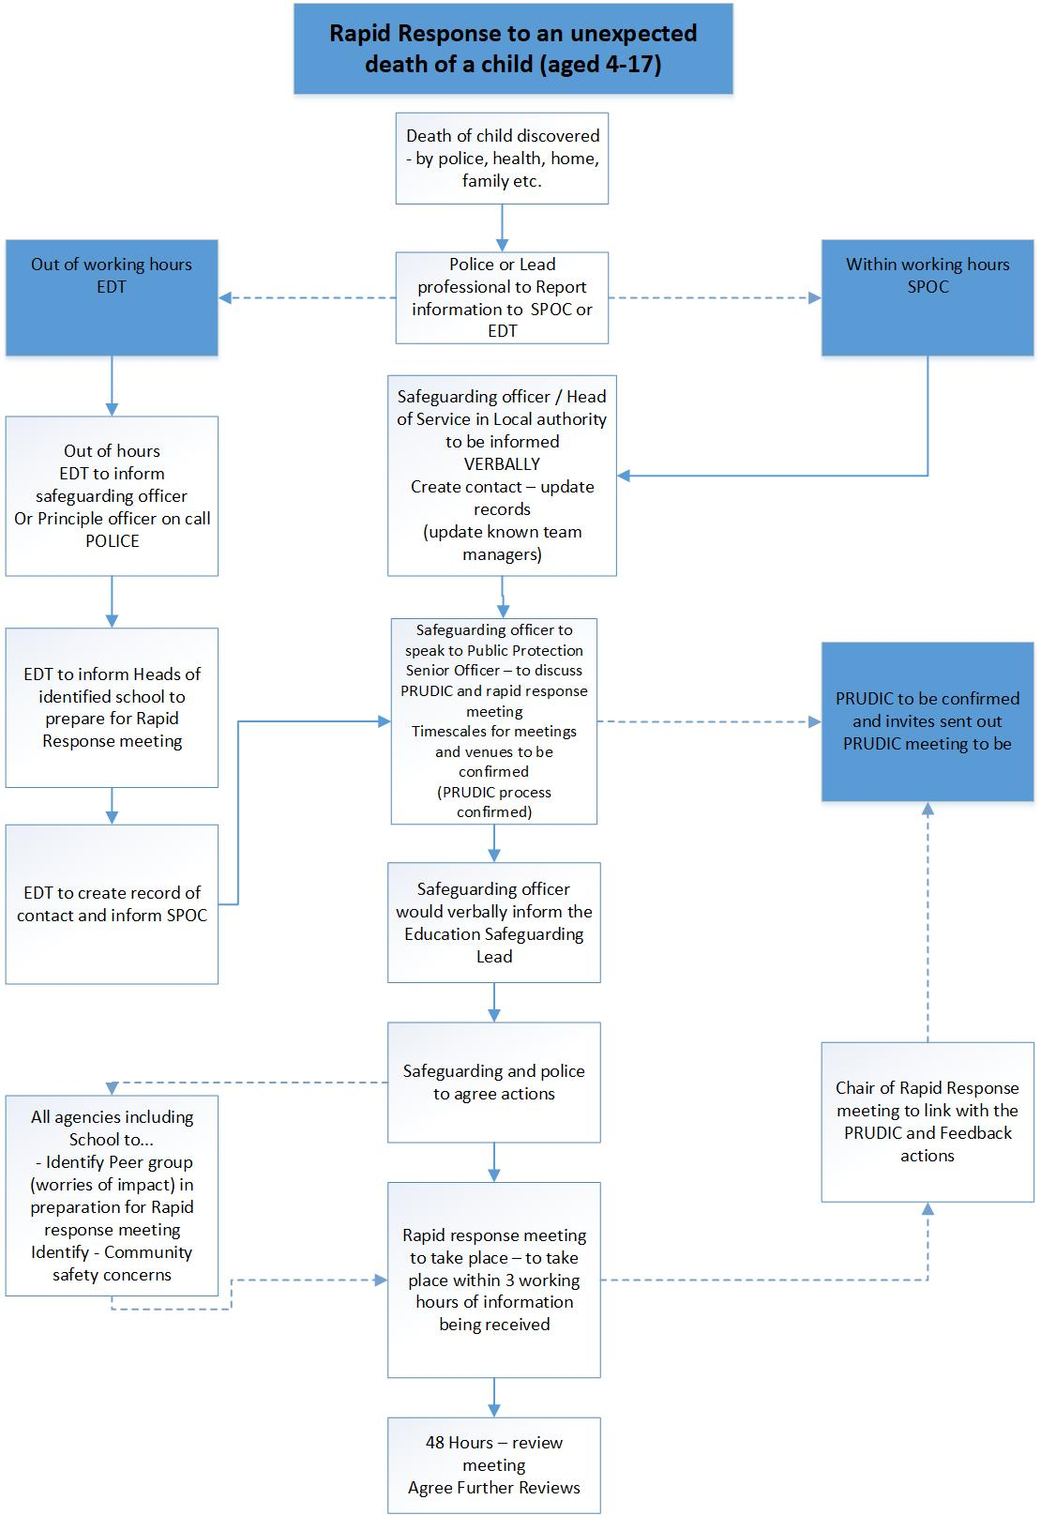

Glossary

EDT – Emergency Duty Team
SPOC – Single Point of Contact
PRUDiC – Procedural Response to Unexpected Death in Childhood

- This process does not replace the PRUDIC, rather this process should work alongside and dovetail with the PRUDIC. While PRUDIC remains the Procedural Response for unexpected deaths, this process will ensure there that wider reaching welfare considerations and impacts are given alongside those identified in the PRUDIC process.

- Out of Office hours if there is an unexpected death of a school aged child this must be reported to EDT who will immediately inform the EDT Principal Officer. If the information is sent out of hours then the EDT PO must notify the Single Point Of Contact at the start of the next working day without any delay. EDT must also notify the Head Teacher of the school that the child attends.

- During office hours when a notification is received (by SSD) of on an unexpected death of a school aged child, the receiving team will bring the case to the attention of the Team Manager and Principal Officer for Safeguarding. The receiving Team Manager must also immediately notify the Safeguarding Officer in Education. Safeguarding Officer in Education to trigger rapid response support for school(s).

- As soon as possible but within 1 working hour the receiving manager or a senior manager will hold a strategy meeting/ discussion with a senior police officer for local public protection to agree the parameters of the rapid response meeting, and whether police or the Local Authority will chair the meeting. This will also consider and ensure that the PRUDIC process is not compromised.

- During office hours SPOC (IIAA)/ receiving team will collect as much information as possible in relation to the child/YP including siblings, peers groups and services involved to assist with establishing who forms part of the peer network but also agencies that will need to be informed.

- When key agencies (Health, Education, Preventative, 3rd Sector and all other agencies working with the family) are contacted, they must collate relevant information that will assist with peer mapping and community safeguarding.

- Any agency/ organisation must identify any immediate risks within their site, to those that access it. If necessary, it is expected that they put in temporary immediate proportionate measures, in line with their policies and procedures.

- A multi-agency strategy meeting to be held within 4 working hours of the information being received (agenda below)

- It will be mandatory for the following professionals to attend the meeting:

Organisation | Representative
South Wales Police | DI for Public Protection  Police liaison for School  Lead Officer for any investigation  Local Community Officer
Local Authority Safeguarding Lead | PO for Safeguarding or PO from Children’s Services in their absence.
Social Services | If Open Case – Childs Social Worker/ Manager/ Practice Lead  Manager/ Practice Lead from IIAA  Manager/ Senior Social Worker from Adult Services Safeguarding Representative.
Child Exploitation Practice Lead | Child Exploitation Practice Lead
Education | Head Teacher/ Deputy Head
Education Safeguarding | Safeguarding officer
Early Intervention Services | Principle Officer  If Open Case – Manager/ Practice Lead  and Lead Worker
Health | Safeguarding Lead from Health Board  Any other identified medical staff as required (identified by safeguarding lead in the Health Board  Head of CAMHS/Relevant CAMHS staff
Housing Department | Lead Identified Professional
Community Safety | Manager
Corporate Communications | Head of Service, Manager
Youth Offending Services | Head of Service, Manager
BAROD | Manager of Team
Exchange Counselling Service/  Samaritans | Manager of Team

Additional Attendees as and when required:

Any other involved support services | As identified
Foster Teams | If Open Case – Childs Social Worker/ Manager/ Practice Lead
Fire Service | Identified Fire Officer
Probation Services | Identified Officer
Welsh Ambulance Service Trust | Safeguarding Lead

- The meeting/ discussion aims to establish hope to establish any children /YP associated with the child/YP that has died. The purpose will be to identify any immediate safeguarding, concerns or support required for the children/YP.

11. The agenda of the meeting will be as follows:
- Introduction
- information gathering and sharing Child/ YP network and circumstances
- Impact of online forums
- Safety of Local Community
- Young People’s safe places
- Who will be the Single Point Of Contact (SPOC)
    - Whole Process
    - Family
    - School
    - Community
What are we doing to support the Children/ Young People and families identified? Who will be leading this?

- What response is required and set a trajectory for the actions agreed.
- What are we doing to support the staff involved.
- Any further actions.
- Date and time of next meeting.

12. The safeguarding lead will agenda a further meeting within 48 hours so that all agreed actions can be communicated and further decision can be made in respect of the children/young people to ensure they are receiving the right support and no further risks have been identified. Following this, further meetings and timescales will be confirmed at each meeting, but these should at least every 6 weeks. The decision to no longer require these meetings is a multi-agency discussion but it will be the final decision of the Chair of the meeting.
13. It is important that throughout these meetings that professional’s consider what matters to the Children, Young People, vulnerable adults and Families that they are supporting.

Information Sharing and GDPR
In ensuring compliance with GDPR, the Council will ensure that this policy is publicly available. In addition, the proactive guidance in respect of how peer group mapping will be carried out will be publicly available.
The objective of these strategic meetings and peer group mapping is to safeguard young people, protecting and promoting their wellbeing, and that this would fall within both the protection of health, and the protection of the rights and freedoms of others.

The Council will engage in peer group mapping in order to comply with its statutory duties to promote the welfare of young people (under the Children Acts of 1989 and 2004 and the Social Services and Wellbeing Act 2014).
Contextual Strategic Meetings will be recorded and minute on WCCIS in line with council data recording policies. Depending on each specific circumstance, consideration is given in regards to each individual how much information is recorded and shared.
Government advice, “Information Sharing: Advice for practitioners providing safeguarding services to children, young people, parents and carers”, highlights that to effectively share information:

•” all practitioners should be confident of the processing conditions, which allow them to store, and share, the information that they need to carry out their safeguarding role. Information which is relevant to safeguarding will often be data which is considered ‘special category personal data’ meaning it is sensitive and personal

• Where practitioners need to share special category personal data, they should be aware that the Data Protection Act 2018 includes ‘safeguarding of children and individuals at risk’ as a condition that allows practitioners to share information without consent

• information can be shared legally without consent, if a practitioner is unable to, cannot be reasonably expected to gain consent from the individual, or if to gain consent could place a child at risk.

• relevant personal information can be shared lawfully if it is to keep a child or individual at risk safe from neglect or physical, emotional or mental harm, or if it is protecting their physical, mental, or emotional well-being.”

Data protection issues arising under the General Data Protection Regulation 2016 (“GDPR”) and the Data Protection Act 2018 (“DPA 2018”). This legislation replaces the regime set out in the Data Protection Act 1998 (“DPA 1998”). As was the case under DPA 1998, the new data protection regime is regulated and enforced by the Information Commissioner’s office (“ICO”), but breaches of data protection law may also lead to proceedings before the Courts.

The purpose of peer group mapping falls within Article 8(2). To some extent, the purpose is to prevent disorder or crime, since the young people with whom the Council are working would in many circumstances be at risk of being victims and/or perpetrators of crime.
For any young person who has been discussed and name identified within the peer mapping the meeting will identify who will inform them and any person who has Parental Responsibility for them and the timescales for doing this. This should be as soon as is practical unless there are specific safeguarding reasons that are evidenced in the meeting that would prevent this.

Terms of reference:
- The meeting has a set agenda and purpose, this is to make sure that any wellbeing and safeguarding concerns are identified in relation to the impact of this child’s death on others. The meeting will identify what support is needed and who will be leading on this.

- The charts below will be the focus of how we will collect the information during this meeting. We would ask all attendees to view the example of information collected and if appropriate bring any relevant information to the meeting with you.

- Attendance at this meeting is mandatory and agreed through protocol. If Lead professional is unable to attend they must ensure that they send a nominated person with delegated decision making responsibilities to attend in your absence.

- The Rapid response meeting will confirm how information is recorded and where it will be stored (SPOC) (WCCIS). All Children, Young People and Families identified through this process will be informed by IIAA that their information is being recorded in regards to the Rapid response of a child death within 48 hours of the initial meet

