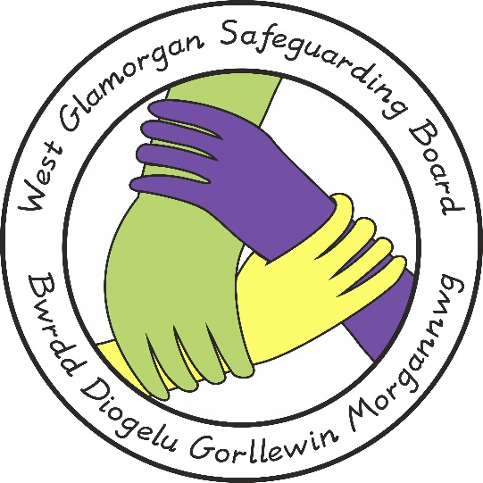

WESTERN BAY SAFEGUARDING CHILDREN BOARD

Child Protection Enquiry Protocol

Document Author: PPP MANAGEMENT GROUP Approved by: WBSCB
Issue Date: 25.07.2016
Review Date: 25.07.2018

CONTENTS

PAGE
- Introduction 3

- Aims & Objectives 3

- Scope Roles & Responsibilities 3

- Legislation 3

- Child Protection Register Check 3

- Child Protection Register Enquiry 4

- Requirements for Abertawe Bro Morgannwg University 5
Health Board

- Requirements for South Wales Police 6

- Local Authority Details 6

- Responses to Child Protection Register Enquiries 7

- Outcomes of an Enquiry 7

- Repeat Enquiries 8

- Child Protection Referrals 8

Introduction

Western Bay Safeguarding Children Board and its member agencies must be compliant with the All Wales Child Protection Procedures 2008 (AWCPP).

Section 3.26 explains that all Local Safeguarding Children Boards (LSCB) should have a system to enable agencies to have access to the child protection register 24 hours per day. Information can be sought from the register by any agency that is a member of the LSCB.

Aims and Objectives

That all membership agencies:
- Distinguish between a child protection register check and a specific child protection register enquiry.
- Know how to make a child protection register check and a child protection register enquiry.

Scope, Roles and Responsibilities

This document outlines the arrangements for membership agencies in the Western Bay.

Legislation
Key legislation and guidance that relates to this Protocol: Children Act 1989 and 2004
Safeguarding Children, Working Together Under the Children Act 2004 All Wales Child Protection Procedures 2008
Data Protection Act 1998
Social Services and Well Being (Wales) Act 2014

Child Protection Register Check

What is a child protection register check?

A child protection registration check will provide basic registration details for all children who are on the Child Protection Register in the Local Authority Area.

It will only provide:

  - Case identification number
  - Name and DOB
  - Address
  - Date registered
  - Registration category
  - Key worker and social work team

A Child Protection Register Check gives no further detail and does not create an automatic notification provided by the child protection enquiry process.
It is important for persons making child protection register checks to be aware that a check will not indicate if there are historical safeguarding concerns including previous child protection registration i.e. it is a check indicating current registration status.

What are the local arrangements?

In some LSCB areas, member agencies have 24 hour access to the register, which allows that agency to do a child protection register check.

In Western Bay area; the following agencies and designations have 24 hour access to the live electronic child protection register to allow them to make a Child Protection Register Check.

  - Staff in Emergency Departments at Morriston Hospital, Princess of Wales Hospital and Neath Port Talbot Hospital Minor Injuries Unit
  - Paediatric Assessment Units at Morriston Hospital and Princess of Wales Hospital
  - Clinical Nurse Specialists Safeguarding Children in Morriston Hospital*
  - Paediatric Liaison Health Visitor*/Senior Ward Staff in Princess of Wales Hospital

* Posts do not cover 24 hour period

South Wales Police are sent copies of child protection register –containing only the 6 pieces of information about the child as listed on page 2.

Membership agencies of the LSCB can also request a check from the Children’s Social Services department in each Local Authority Area by contacting them directly. See Section 6 for contact details.

Child Protection Register Enquiry

What is a Child Protection Register Enquiry?

The main purpose of a CP register enquiry should be to;

  - Assist in informing the decision making of professionals with concerns that a child may be at risk of significant harm and
  - To ensure that they are fully aware of any previous or current child protection concerns as part of the decision making process.

To make a child protection register enquiry children’s social services must be contacted – See Section 6.

A child protection register enquiry is not a referral. However it is an additional way that professionals can gain information about a child for whom they may have concerns about possible risk of significant harm, in order to inform their decision about the need to intervene further, including whether to make a child protection referral.

Enquiries to the register must never be seen as a substitute for appropriate discussion of concern with social serves and an appropriate child protection referral.

If sibling details are known, the enquirer should make a child protection enquiry for each child.

A Child Protection Register enquiry will provide the registration status of the child, and, if registered:

- The category of registration;
- The date of registration
- The name and contact details of the key worker and all involved social services staff
- Known associated people (family)
- Previous registration details; including date registered and de- registered
- Detail of previous enquiries, including date of enquiry, instigator, reason and action
- Strategy discussion history, including date, social work team involved and outcome
- Section 47 history, including date, alleged abuse category and outcome
- Case conference history

Requirements for Abertawe Bro Morgannwg University Health Board

Hospital procedure for all children admitted to the Emergency Departments or Minor Injuries Unit and/or Paediatric Assessment Units within ABMUHB is for a routine check to be made of the child protection register (child protection register check). This routine check should be undertaken at the point of admission.

It is the responsibility of all ABMUHB staff to formally make a child protection register enquiry where this is assessed as appropriate.

In addition, the Clinical Nurse Specialist Safeguarding/Children, Paediatric Liaison Health Visitor or Senior Nurse will make a child protection register enquiry , at the point of admission, for all paediatric admissions under 1 year of age and review the necessity for a child protection register enquiry for older children.

For children less than 1 year of age with chronic health conditions which may necessitate repeated hospital attendances, further Child Protection Register enquiries will only be conducted if safeguarding concerns arise.
Similarly, a Child Protection Register enquiry will not be undertaken for children less than 1 year old admitted for planned surgery unless staff identifies safeguarding concerns.

Requirements for South Wales Police
Every child named on the child protection register will have a warning marker alerting to the registration on the police IT system in addition to other relevant case information that may be held on the police IT niche system.

It is the responsibility of the Police to formally make a Child Protection Register Enquiry where this is assessed as appropriate.

Local Authority Details

Swansea Local Authority

All Child Protection Register Enquiries must be made to Child and Family Services as follows:

Office Hours | Outside Office Hours
08.30 -17.00 Monday to Thursday  08.30-16.30 Friday | Outside office hours – Emergency  Duty Team
Tel: 01792 635700 | Tel: 01792 775501
CCARAT@swansea.gov.uk
CCARAT2@swansea.gcsx.gov.uk
The Children’s Central Advice Referral and Assessment Team (CCARAT) 36 Orchard Street Swansea SA1 5LD

Neath Port Talbot Local Authority

Office Hours | Outside Office Hours
08.30 -17.00 Monday to Thursday  08.30-16.30 Friday | Outside office hours – Emergency  Duty Team
Tel: 01639 686070 | Tel: 01639 895455
dutyintake@npt.gov.uk
dutyintake@npt.gcsx.gov.uk
Civic Centre, Neath, SA11 3QZ

Bridgend Local Authority

All Child Protection Register Enquiries must be made to Child Protection clerks as follows:

Office Hours | Outside Office Hours
08.30 -17.00 Monday to Thursday  08.30-16.30 Friday | Outside office hours – Emergency  Duty Team
Tel: 01656 642317 | Tel: 01443 849944
childprotection- businesssupport@bridgend.gov.uk

childprotectionbusinesssupport@brid gend.gcsx.gov.uk
Sunnyside Offices, Bridgend, CF31
4AR

Responses to Child Protection Register Enquiries
The enquirer will be contacted within 2 hours of making the enquiry to confirm enquirer details and to be provided with the response to the enquiry with any other relevant details and advice.

Within 24 hours the Enquirer/Enquiry details will be recorded by social services including the nature and reason for the enquiry.

Where sibling details are known, a separate CP enquiry for each child must be recorded.

Outcomes of an Enquiry
If a child’s name is on the register, the enquirer must notify the key worker (child’s social worker) of their concern (this must include any sibling information). The key worker’s details will be given as part of the response to the enquiry.

The custodian of the child protection register should also notify the key worker of any enquiry regarding a child on the register, or a child at the same address as a child on the register.

The Custodian of the register is the Senior Manager in Children’s Social Services with lead Safeguarding responsibility.

If an enquiry is made but the child’s name is not on the register this should be recorded together with the advice given to the enquirer.

In all Cases - Irrespective of whether the Child’s name is or has been on the register the professional making the check or response must;

  - Consider the circumstances and available information from all sources and
  - Make an assessment and use their professional judgement to decide whether a child protection referral or referral for services is required.

Repeat Enquiries
In accordance with AWCPP in the event of two enquiries for a non-registered child being made in a six month period an automatic IT prompt will be sent to the senior manager in social services with responsibility for child protection.

The details will then be considered to establish whether an initial assessment or other intervention may be required for that child. In the event of a second enquiry about a non-registered child the custodian should inform:

  - The second enquirer about the first enquiry;
  - The first enquirer about the second enquiry

Child Protection Referrals
The AWCPP state that whenever a child protection referral is received by social services, an enquiry of the CPR should be made as part of the initial assessment process.

