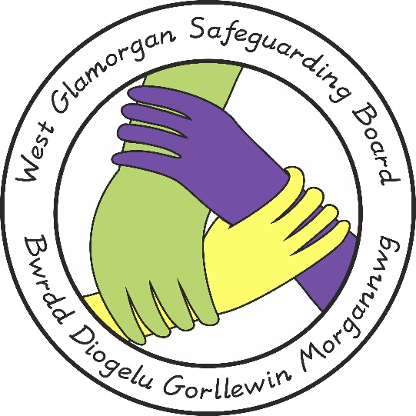

WEST GLAMORGAN SAFEGUARDING BOARD

ESCALATION TO COMMISSION AN EXTERNAL INDEPENDENT CHAIR AND REVIEWER FOR A PRACTICE REVIEW

Document Author: Practice Review Management Group (PRMG)
Approved by: West Glamorgan Safeguarding Board
Issue Date: 24th September 2020
Review Date: 24th September 2020

Introduction

The Social Services and Well – being (Wales) Act 2014 Working Together to Safeguard People, Part 7 Volume 2 and 3 respectively sets out the guidance for conducting Child and Adult Practice Reviews.

The criteria for Child and Adult Practice Reviews are laid down in the Safeguarding Boards Functions and Procedures (Wales) Regulation 2015. The arrangements came into Force from 6th April 2016.

The overall purpose of the review system is to promote a positive culture of multi-agency child and adult protection learning in local areas in which Board and partner agencies hold responsibility.

To achieve this, it sets in place a foundation for learning together by professionals from different agencies and, in those circumstances where a more formal review is required when there are serious incidents resulting from abuse or neglect, there is a system of multi-agency, concise and extended Child and Adult Practice Reviews, Historical reviews and MAPFs (Multi Agency Professional Forums).

The framework has a number of important features, some of which impact on the requirement of this process.

It involves agencies, staff and families in a collective endeavour to reflect and learn from what has happened in order to improve practice in the future, with a focus on accountability and not on culpability.
It strengthens the accountability of managers to take responsibility for the context and culture in which their staff are working and to see that they have the support and resources they need.
It recognises the impact of the tragic circumstances of non-accidental child deaths or serious harm on families and on staff, and provides opportunities for serious incidents to be reviewed in a culture that is fair and just.
It takes a more streamlined, flexible and proportionate approach to reviewing and learning from what are inevitably complex cases.
It allows a more constructive and appropriate use of resources and works to shorter timescales.

It focuses on key learning identified through the review process which results in relevant recommendations and actions to improve future practice, recorded in anonymised reports which are published by Boards.

The review is managed by a Review Panel and a Reviewer/s is appointed to work with the Panel. For ease, the Reviewer is identified in the PRMG once it has been agreed that the referral meets the criteria of a Practice Review, Historic Review or MAPF.

The Reviewer engages directly with children, adults and family members, as they wish and as is appropriate, so their perspectives are included, and it involves practitioners who have been working with the child, adult and family, and their managers.

A planned and facilitated practitioner-focused learning event is a key element of the review, conducted by the Reviewer/s, to examine current case practice within a limited timeline and using a systems approach.

When choosing a Reviewer/s the PRMG members have to remember that the knowledge and the experience of the Reviewer is crucial to the quality of the outcome. The role requires a wide range of knowledge, skills, and abilities which include thorough knowledge of both Adult and Child Protection systems, issues, responsibilities and practice, an understanding of multi – disciplinary working, an ability to enquire and communicate about practice with professionals and with children, adults and family members, and skills in facilitating and managing group processes effectively.

In appointing a Reviewer, West Glamorgan Safeguarding Board will need to be satisfied that safe recruitment practices have been observed. In certain circumstances there may be a need for the PRMG to defer the decision to appoint a reviewer to the Board.

Circumstances when the PRMG should consider escalating to the board for a decision on commissioning an External Independent Reviewer.

- When the review is so complex and/or specialist and after consultation it is considered that the available resources within the respective agencies would not have the necessary expertise or skill set to ensure an efficient and effective review that would stand independent scrutiny. This may be instead of or additional to a professional business expert advisor to the panel.

- In such circumstances where there is such an unprecedented number of referrals meeting the criteria for a Practice Review and as a consequence of that it is not possible to identify suitably qualified resources across partner agencies to commit to the role of Reviewer/Chair.

- Where conflict of interest has been identified between the family and any of the agencies involved which has the potential to jeopardise the effectiveness of the process and cast doubt on the transparency of the process from the family’s or others’ perspective.

This list is not exhaustive.

Process

The PRMG decision about how to proceed on receipt of the referral will be forwarded as a recommendation to the West Glamorgan Safeguarding Board in the usual way with an accompanying report with the reason and rationale for commissioning an External Independent Reviewer.

- A brief outline of the circumstances of the case
- The reason for holding the Concise/Extended/Historical Review or MAPF
- The proposed Terms of Reference
- A timeline of the Review
- If it is considered that one of the above criteria or similar criteria is met and the commissioning of an External Independent Reviewer is recommended by the Sub Group the accompanying report will be submitted for Board approval. The report must include
- The reason and rationale
- The Time scales
- The proposed Person i.e. Chair / Reviewer or both.
- The estimated cost.
- If agreed the Business Unit will take responsibility for the procurement of the Independent Reviewer/s and /or Chair via a robust process that will stand independent scrutiny.

Acknowledgements

In completing this guidance the following were used as reference materials:

1. Social Services and Well Being (Wales) Act 2014
2. Working Together to Safeguard People Volume 2 – Child Practice
3. Working Together to Safeguard People Volume 3 – Adult Practice Review

If you have any queries about the content please contact:

Rebecca Shepherd
Business Manager – West Glamorgan Safeguarding Board
Tel/ Ffôn: 01639 686049
Mobile: 07964 246849
Email: r.shepherd@npt.gov.uk
Website/ Gwefan – www.wgsb.wales

