West Glamorgan Safeguarding Board

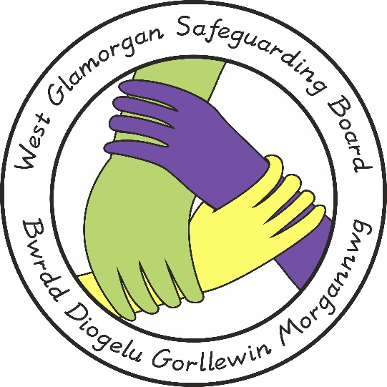

Complaints Procedure for

Practice Reviews

Document Author: Policy, Practice & Procedure Management Group
Approved by: WGSB
Issue Date: June 2020
Review Date: June 2023

Child and Adult Practice Reviews

The Welsh Government statutory guidance (Volumes 2 & 3 of 'Working Together to Safeguard People'), issued in accordance with the Social Services & Wellbeing (Wales) Act 2014 requires Safeguarding Boards to have a process in place to manage complaints in relation to Child & Adult Practice Reviews. This process needs to take into account the multi-agency nature of Practice Reviews.

What can be Complained About?

Any person directly involved or affected in the adult or child practice review process can make a complaint that will be considered by the Board. Complaints will be considered in respect of one or more of the following aspects of the process:

▪ The decision on whether or not to proceed with a Child or Adult practice
Review;
▪ The process followed in terms of adherence to the statutory guidance
▪ The content of the report

Stage 1 - Resolution by West Glamorgan Safeguarding Board Co-Chairs

The West Glamorgan Safeguarding Board is committed to resolving complaints at the earliest opportunity and at a local level where this is possible.

A complaint should be made in writing or by telephone to the West Glamorgan Safeguarding Board Co-Chairs via the Business Manager. The Co-Chairs will attempt to resolve the complaint within 10 working days of receiving the complaint. If the matter is resolved, the Business Manager will send a response letter to the complainant confirming the agreed resolution and inform the Chair of the Practice Review Management Group and the Chair of the Review Panel, if appropriate

If the complaint is not resolved, the Business Manager should inform the Chair of the Safeguarding Board's Practice Review Management Group that the complainant wishes to go to next stage of the procedure, the Interagency Safeguarding Board Complaints Panel.

The complaint at this stage will need to be in a written format. The person making the complaint may need to be assisted in putting their complaint in a written format (see Appendix 1).

Stage 2 - Inter-agency Complaints Panel

The Business Manager will convene an Inter-agency Complaints Panel. The panel should consist of a minimum of three representatives from the Board, one of whom will act as chair. The Panel shall not include any agency that has had direct involvement in the case/review.

The Business Manager will circulate all relevant documentation to members of the panel including the original complaint and any relevant reports.

The complainant will be advised of the meeting and be provided with an opportunity to attend. They will be entitled to be accompanied by a person of their choice.

At the Panel meeting the chair will be responsible for:
▪ Introducing the meeting and explaining its purpose
▪ Explaining what the Panel will and will not consider
▪ Outlining any previous measures that have attempted to resolve the complaint and any background issues.
▪ Providing the complainant with an opportunity to make a statement in person or in writing to the panel and call evidence relating to his/her complaint.

Both the panel and the complainant may call witnesses.

The Panel has 25 working days from the date that the complaint was signed to inform the complainant of their findings.

Decision of the Panel
The Complaints Panel will determine:
▪ Whether the process followed adhered to the statutory guidance under Part 7 of the Social Services and Wellbeing (Wales) Act 2014, Volumes 2 and 3 on Child and Adult Practice Reviews;
▪ Whether the decision that is being complained about followed reasonably from the proper observation of the statutory guidance;
▪ Whether the decision that is being complained about followed reasonably from the information available to the original Practice Review Management Group meeting or CPR/APR Panel.

The Business Manager will write to the complainant informing them of the decision of the panel. Copies of the letter will be sent to:

▪ The child/adult at risk, if appropriate
▪ Any other person with care-giving responsibility if appropriate
▪ The Chair of the Practice Review Management Group
▪ The Chair of the CPR/APR panel, if appropriate
▪ Any other relevant person involved in the case that is identified by the Panel

The Complaints Panel can recommend that the original Practice Review Management Group meeting or CPR/APR Panel is reconvened to take account of the Panel’s findings. A different Chair can be nominated and the meeting reconvened within 15 working days of the panel decision.

If any part of the complaint is upheld the Complaints Panel will refer their recommendations to the reconvened meeting. The original decision will remain in place until the reconvened meeting has taken place.

In some cases complainants may raise concerns about individual agencies during the course of the Panel meeting, should this happen and the information provided raises concerns about the quality of practice within that agency, the Chair of the Panel will discuss these with the designated senior manager of the agency concerned immediately following the Panel meeting.

Reporting

The number of complaints resolved at Stage 1 of the Child or Adult Protection Meetings or Conferences will be reported by the Manager for Child/Adult Protection to the Quality and Performance Management Group.

Information regarding complaints made under Stage 2 of the Child or Adult Protection Meetings or Conferences will be reported to the relevant Child or Adult Quality Assurance Group by the West Glamorgan Safeguarding Board Business Manager.

All complaints relating to the Adult or Child Practice Review process will be reported to the Practice Review Management Group by the West Glamorgan Safeguarding Board Business Manager.

Appendix 1 – West Glamorgan Safeguarding Board Complaint Form

Name of person involved:
Address:
Date of meeting (if applicable):
Chair of meeting (if applicable):
Name of person making the complaint:
Relationship to the person above:
Address:
Telephone number:
E-mail address:

Please provide details of your complaint below (continue on a separate sheet if required):

Signed: Date:

Please return to:

West Glamorgan Safeguarding Board Business Manager
Safeguarding Unit
Civic Centre
Neath
SA11 3QZ

Or via email to:- r.shepherd@npt.gov.uk

