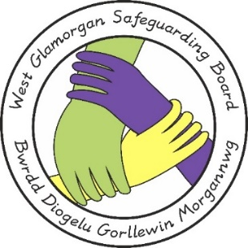

**CPR N56 ACTION PLAN**

| **NO** | **RECOMMENDATIONS** | **ACTIONS NEEDED** | **RESPONSIBLE** | **TIMESCALE** | **OUTCOME** | **DATE COMPLETED** |
| --- | --- | --- | --- | --- | --- | --- |
| 1 | To comply with General Data Protection Regulation, agencies need to strengthen their guidance and training provided in respect of recording information. This will ensure relevant individuals are identified clearly in recordings whilst also differentiating between self-reported information and diagnosed conditions. | Agencies to review current guidance and training in respect of recording of information. Guidance/training to be developed if not in place. | All agencies. | February 2024 |  |  |
| 2 | Following the initial sharing of safeguarding information via the SIP process, midwifery and health visiting services are to be reminded of the importance of effective communication and information sharing between their services in the on–going pregnancy. | Health to share  7 minute briefing with all staff.  Include the importance of on –going effective two way communication at Midwifery and Health Visiting statutory safeguarding training. | Health. | August 2023  To be included in next cohort of safeguarding training (April 2024 – completed by all March 2025) |  |  |
| 3 | When support staff are delegated a task, it is essential that any area of concern is communicated back to the case holder in a timely manner. | All agencies to share 7 minute briefing with staff. | All agencies | August 2023. |  |  |
| 4. | All agencies to be reminded of the importance of including all key agencies at the Initial Strategy Meeting. | All agencies to share 7 minute briefing with staff. | All agencies. | August 2023. |  |  |
| 5 | Agencies need to be reminded of duties to involve those who have parental responsibility. Training needs to include the importance of involving fathers and extended family to fully assess risk and maximise opportunities for better outcomes. | All agencies to update training to reflect the importance of involving fathers and extended family to fully assess risk | All agencies. | February 2024. |  |  |
| 6. | Agencies need to be reminded that if the referring agencies are not content with the proposed action they must challenge the decision and if necessary escalate their concerns by implementing the *Multi-Agency Protocol for the Resolution of Professional Differences (2020)*. | All agencies to share 7 minute briefing with all staff. | All agencies. | August 2023. |  |  |
| 7. | Panel Members must be reminded of their responsibilities in the Child Practice Review process which includes that all key professionals involved in the case are invited to the Learning Event to maximise discussion and learning. | All agencies to share 7 minute briefing with staff. | All agencies | August 2023 |  |  |