7 Minute Briefing – WG N56/2020
7) Seven Recommendations
2) Key learning Themes

1) Background

- Agencies need to strengthen their guidance and training provided in respect of recording information.
- Following the initial sharing of safeguarding information via the Sharing Information in Pregnancy (SIP) process, midwifery and health visiting services are to be reminded of the importance of effective communication and information sharing between their services in the on–going pregnancy.
- When support staff are delegated a task, it is essential that any area of concern is communicated back to the case holder in a timely manner.
- All agencies to be reminded of the importance of involving all key agencies at the Initial Strategy Meeting.
- Agencies need to be reminded of duties to involve those who have parental responsibility and involving fathers.
- If agencies are not in agreement with the proposed action they must implement the Multi-Agency Protocol for the Resolution of Professional Differences (2020).
- Panel Members must be reminded of their responsibilities in the Child Practice Review process which includes that all key professionals involved in the case are invited to the Learning Event to maximise discussion and learning.

The subject of this review was Child X who at six months old was admitted to hospital in December 2019 with injuries that were believed to have been caused by being shaken. On admittance to hospital bilateral macular haemorrhages were diagnosed. Parents were unable to provide an explanation.
A number of tests were carried out confirming that child X had sustained multiple subdural haemorrhages. A consultant neurologist noted three level of bleeds indicating three separate injuries at differing times consistent with a car accident, diving, or having been shaken.

Child X has two half siblings with a different father to child X. Both Child X’s half siblings lived between both mother and their father.

- Multi Agency working.

- The power of language.

- Working with domestic violence.

- Professional curiosity.

3) Multi Agency Working
There were a number of agencies involved with the family however, there was little evidence of collaborative working. There were inconsistencies in the information given by mother in her relationship status however this was not shared amongst agencies in order to assess and triangulate the information provided. Health professionals communicated their safeguarding concerns however this did not proceed to a multiagency meeting or child protection. Health professionals did not implement the Multi-Agency Protocol for the Resolution of Professional Differences (2020).

A community nursery nurse noted a smell of cannabis during a home visit but was no evidence to show this was fed back to the case holding Health Visitor so this was not further explored during subsequent visits.

There was a missed opportunity to pull all agencies together to share relevant information. Having a clear single multiagency plan may have supported further partnership work between agencies. There was no early assessment or care support plan which would have supported understanding of historical and ongoing risk.

6) Professional Curiosity
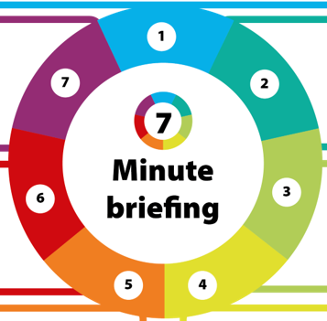
Mother continued to deny the relationship with Child X’s father yet they were often noted in recordings as being together. Lack of communication and professional curiosity created a barrier to fully exploring this. The risk of experiencing domestic violence or abuse is increased in women who have a mental health problem, and around the time of separation yet we often see this as a positive move that would reduce the level of risk. It would appear that mother’s needs detracted the Local Authority and other agencies from reviewing this despite the historical concerns.


4) The Power of Language
Throughout this case mother is identified as having Post Traumatic Stress Disorder (PTSD). This was repeated in a number of agency recordings and became fact despite a later assessment confirming mother did not have PTSD. This identified the importance of accurately recording where someone has been diagnosed or is self-reporting as this can influence how this person is then worked with.

When reviewing the timeline there were a number of entries where mother was noted to attend health appointments with ‘partner’ however we could not identify who this individual was. This again raised the importance of recording and identifying names of who is in attendance.

5) Working with Domestic Violence

Agencies developed a shared bias of the ex-partner due to mother’s comments. The Learning Event questioned whether the reported domestic violence in this case clouded the concerns expressed by ex-partner leading up to Child X’s injury.

There was limited contact between professionals and Child X’s siblings’ father (ex-partner) to be able to fully understand and assess mother’s parenting. There were no observations of parent child interaction or opportunities for the children to have their views heard. Health were only visiting the children at mother’s address.

