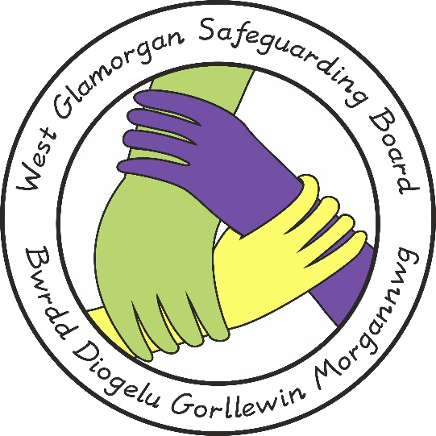

West Glamorgan Safeguarding Board

Practice Review

Multi-Agency Timeline Guidance

Document Author: POLICY, PRACTICE & PROCEDURE MANAGEMENT GROUP
Approved by: WGSB
Issue Date: 16 July 2019
Review Date: 16 July 2025

West Glamorgan Safeguarding Board
Practice Review Multi – Agency Timeline Guidance

Contents

Introduction 3

Practice Review Multi – Agency Timelines 3

The Format Explained (Appendix 1) 4

When to Complete a Multi – Agency Timeline? 4

How to Compile / The Format Of A Multi – Agency Timeline? 5

What to Record in a Multi – Agency Timeline? 5

Acknowledgements 6

Appendix 1: Timeline Format 7

Introduction

This guidance has been developed in response to a Serious Case Review. The review concluded that professionals would have had a better understanding / overview of the case if they had access to an up to date timeline, either single or multi-agency.

A completed multi-agency timeline is instrumental to the Practice Review process and assists the panel in understanding the case, identifying key people to attend the learning event for the review and to best share any organisational learning points highlighted from the review.

Practice Review Multi Agency Timelines

A timeline is required specifically as a part of the Child Practice Review (CPR) / Adult Practice Review (APR) process and once amalgamated to a multi-agency timeline, is a useful tool to be used by the Practice Review Panel to assist in the analysis and understanding of a case, case related activity and decision making. A single agency Timeline does not provide a complete picture of the family’s life and circumstances, only combined multi-agency Timelines can do this. In addition to the multi-agency aspect, the Timeline format allows for the author to provide some analysis of actions taken or decisions made as well as assisting the panel when lesson learning is being considered.

Attached to this document is a suggested format that can be used across all agencies, statutory or voluntary.

Across West Glamorgan; a software tool is used across West Glamorgan to assist in the completion and merging of multi-agency timelines.

It is important for the relevant person to complete the timeline for their agency. This does not have to be the panel member but there is an expectation that the person completing the timeline is independent of the case and has sufficient knowledge of the relevant information being included; if they are unsure they can refer to their panel member.

It should also be noted that, whether they complete the timeline or not, the completion of the timeline is ultimately the responsibility of the panel member. The panel member also needs to confirm they have read and agree with the content before it is submitted to the WGSCB Business Management Unit (BMU)

The Format Explained (Appendix 1)

- Column 1: Date
- Column 2: Time
- Column 3: Source of Information – Where has this information come from e.g. Education, next door neighbour etc.
- Column 4: Significant Event – explain what has taken place e.g. child protection medical has taken place at the hospital and Paediatrician has concluded it was accidental/non accidental; or someone has moved into or out of the home address. Make sure you include who was there, who saw what / said what as far as is possible.
- Column 5: Analysis – a brief summary of the agency’s view on whether there was any good practice, missed opportunities, whether the voice of the person was considered.

When To Complete A Multi – Agency Timeline?

When a decision is reached by the Management Group that a Practice Review will be undertaken; relevant individual agencies will be required to access the child’s/adult’s record and submit a timeline.

Consequently when the completion of a multi-agency all relevant professionals are to ensure that information describing key incidents/events/information is passed on to the Timeline author in the agreed format (see appendix 1). This can be done by email, or on paper. The information held by agencies not part of the multi-agency planning team may also need to be accessed and consideration will need to be given as to how this will be done.

The BMU will be responsible for collating the information each agency individually provides into one combined multi-agency Timeline.
It is important to be clear about where the information has come from e.g. Education. There may be more than one source of the same information. You will still be able record form which agency records this information has been taken, who were involved and all other information, under the relevant columns of the Timeline template (appendix 1).

Professionals need to consider what records can be used to inform their completion of the Timeline. For example, this could include information from previous Child Protection Conference Minutes or assessments, GP records and hospital records, Local Authority, Education records and school records however this list is not exhaustive and each agency will have a variety of sources of information from which to contribute to the Timeline.

How to Compile/The Format of a Multi-Agency Timeline?

In order to assist the compiling of different agencies information, an electronic template will be circulated, based upon the attached template (Appendix 1). This will enable the BMU to easily combine this information into one working multi-agency Timeline that can be shared as part of the review.

All BMU should ensure the template ad guidance document is readily available for authors to access.

What to Record in a Multi-Agency Timeline?

A Timeline provided a concise sequential story of significant events in a family’s history. It contributes to an emerging picture, based on fact and interactions of a case – information can then be understood in the context of previous information, thus informing the review.

A significant event is an incident that impacts on the child’s safety and welfare, circumstances or home environment, This will inevitably involve a professional decision and/or judgement based upon the child/persons individual circumstances, It is important that a Timeline is not a repeat of the records you hold for this child/person, it should include significant events/circumstances only.

There are a number of core incidents/circumstances, which should be recorded. Dependent upon the nature, these may differ from case to case. Therefore this is not an exhaustive list.

Examples include:

- A significant observation during home visits e.g. the frequent presence of unknown adults, evidence of damage to the property, negative interactions between parent and child, poor home conditions found on visit etc.
- If Timelines are to accurately reflect family circumstances, relevant/significant positive/significant positive factors should also be recorded (e.g. families’ engagement with professionals, child’s presentation in school significantly improves etc.).

It is essential that practitioners use their professional judgement in identifying any pertinent information. There is a risk that a mechanical approach to completing a Timeline that automatically records predetermined ‘key facts’ could weaken the focus and role of professional judgement which are vital to effective practice. A Timeline must never become an end in itself.

Acknowledgements

In completing this guidance and the accompanying template, the following were used as reference materials:

1. All Wales Child Protection Procedures, 2008
2. “Safeguarding Children Procedures, Multi Agency Chronologies” – Blackpool Local Safeguarding Children Board, 2008
3. “Durhan LSCB Child Protection Procedures – Managing Individual Cases” – Durhan Local Safeguarding Children Board, 2010
4 “Practice Guide: Chronologies” Social Work Inspection Agency, Scotland, 2010
5. Social Services and Well Being (Wales) Act 2014
6. Working Together to Safeguard People Volume 2 – Child Practice Reviews
7. Working Together to Safeguard People Volume 3 – Adult Practice Reviews

Appendix 1: Timeline Format

Family Composition

Include every person living in the home, significant other family members e.g. father who lives elsewhere, other children living elsewhere.
Include dates of birth and addresses.

DATE | TIME | SOURCE OF INFORMATION | SIGNIFICANT EVENT | ACTION TAKEN | ANALYSIS/ COMMENTS

Contact
If you have any queries about the content of the attached document, please contact:

Rebecca Shepherd
Business Manager – West Glamorgan Safeguarding Board
Tel/ Ffôn: 01639 686049
Mobile: 07964 246849
Email: r.shepherd@npt.gov.uk
Website/ Gwefan – www.wgsb.wales

