7 Minute Briefing Template

7) Recommendations
2) Key Learning Themes
1)Background

Exploitation training should be reviewed to consider the impact of gender bias.
Exploitation guidance should be re-circulated via WGSB members.
Practice guide on professional curiosity to be re-circulated via WGSB members.
Training should be developed/identified to develop practitioners’ skills in using professional curiosity and challenge and guarding against over-optimism.
All agencies, whilst recognising the role of a lead agency, must be mindful not to become over-reliant on an individual staff member.
Practitioners should be reminded of the need to check records, avoid assumptions, or rely on word of mouth.
Training is required across all agencies on the trauma informed approach to working with children and families.
The use of Teams and virtual learning events needs to be reconsidered by the WGSB.

The subject of this review, Child A, was admitted to hospital aged 17 following an overdose of heroin. At the same time Adult B, with whom he had been residing, was pronounced dead following overdose.
Information indicates a troubled home life with both parents having issues with substance misuse. Child A began using illicit substances form around age 11/12 and he acknowledges he became immersed in a lifestyle difficult to escape.
Child A was known to YJS from age 12. He had been linked to a variety of offences but had also been considered a victim of criminal exploitation.
Child A had unmanaged epilepsy and his seizures were worsened by his chaotic use of substances. Child A and Adult B were considered to be in a “relationship” and this was not raised as potential child sexual exploitation.
Child A is now well and was able to share his own insight with reviewers.
- Gender bias
- Recognising exploitation
- Disguised compliance & Professional curiosity
- Impact of Covid
- Non-attendance at appointments
- Over-reliance on a single agency/practitioner
- Missed statutory timescales
- Assumption/inaccurate records
- Panel membership
- Suffering trauma on trauma
- Caring for practitioners

3) Gender Bias and Exploitation
Child A was not considered a victim of CSE despite him being a 16 year old with a 28 year old “girlfriend”. Practitioners, on the whole, failed to recognise that he was a victim because Adult B was considered a positive and nurturing person in his life.
The fact that this did not fit the stereotypical idea that CSE involves an older adult male and because the victim was an adolescent seemed to distract the agencies from pursuing an exploitation response.

6) Suffering Trauma on Trauma
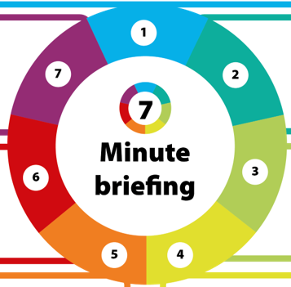
4) Disguised Compliance and Professional Curiosity
5) Over-reliance on a single agency/ practitioner
Child A suffered trauma throughout his life. This included the neglectful parenting, drug use and separation of his parents.
His own medical history was complex and he suffered from epileptic seizures, a frightening occurrence that often happened when he was alone, without parental support. During the period of the timeline he was hospitalised with an open fracture to his leg, whilst at the same time there was a medical emergency involving his brother which took some of the support from child A.
The review panel highlighted the need to ensure incidents/occurrences are not looked at in isolation. To support children and young people who have experience multiple traumatic events practitioners should have accessed training on ACEs and trauma. A trauma informed approach is essential to prevent compounding and adding to the suffering of any individual.


Practitioners accepted, as positive, the engagement of parents. However, this engagement was sporadic and often on the parents’ terms. Parental substance misuse, missed medical appointments for child A, father’s involvement in criminality were all evidence of a general neglect of Child A’s basic needs.
Practitioners were not actively curious and did not challenge sufficiently to identify the safeguarding concerns.
In addition there was a feeling that practitioners were over-optimistic about the parents’ ability to provide safe care.
The multi-agency timeline produced by the review panel clearly indicated not only an over-reliance on one agency but in particular on one staff member.
Child A had formed a positive bond with this worker who he felt took the time to listen to him. In fact Child A described the worker as his only safe adult.
The impact of managing a complex case is significant but requires a multi-agency approach to ensure the wellbeing of the child and the practitioners.

