7 Minute Briefing APR - WGA S25 2023

7) Learning: Communication across Systems
2) Context
1) Background

The review found that whilst there are mechanisms for information sharing between WAST and GPs in many scenarios, where calls made to WAST do not progress past the initial call handler stage, information is not shared with GPs. When an ambulance was requested to get Adult A back in to bed after a fall in 2021, the clinical Safety Plan directed that an ambulance could not be sent. The Learning event found that had this information been shared with the GP, it could have indicated the need to ‘check in’ with Adult A. The Review recognised that the linking of data across agencies is required to improve information sharing and outcomes for adults at risk.
A concise APR was agreed by the PRMG in relation to the circumstances leading to the death of Adult A, a 65-year-old woman who lived alone and had been bedbound for a number of years. Paramedics attended the address following a call from Adult A’s brother and upon examination found her to have gangrene present in her lower limbs, faeces present and maggots living within her. The Fire Service were called to assist in moving her from the address as she had become fused to her mattress and police were called due to comments made by her brother and a friend who was present which raised concerns around neglect. Adult A died in hospital 4 days later. The brother and friend were arrested and following investigation were released without charge.
The multi-agency timeline produced only 5 entries despite considering a period of 18 months. Historical information provided documented Adult A’s poor compliance with health interventions to address foot and leg ulcers back to 2009. In 2015 it was documented that she was dressing her ulcers at home. Adult A had 2 falls (2017 & 2018) and declined social input on discharge. There had been some OT involvement with Adult A between 2014 and 2018, with evidence of non-engagement, non-acceptance of interventions and challenges around contact.

3) Learning: Self Neglect
6) Learning: Withdrawal from Services and Thinking Family
The term self-neglect did not appear in any of the records and neither did practitioners at the learning event use this terminology to describe Adult A’s behaviour and circumstances. Adult A behaved in a way that some professionals found challenging and at times upsetting. The view of Adult A as forceful and challenging appeared to prevent professionals from understanding her behaviour as self-neglect, and rather this appeared to be seen as a choice that she was making,
Withdrawal from Services
Adult A had been a frequent attender at the surgery but by 2019 had almost completely withdrawn from services. There was no alert or flagging system in place for individuals who self-neglect to allow for any monitoring or escalation when interventions were declined or contacts unsuccessful. There were also missed opportunities to re-engage with Adult A via a medication review and when she made a call to the surgery out of the blue to ask about her prescription being withheld for bandages.

Thinking Family
Adult A’s brother told the Reviewers that he asked for help for his sister on a number of occasions but was told that she would have to seek help herself as a capacitated adult. This should not have stopped practitioners listening to her brother’s concerns and incorporating these into assessments. There was no evidence of consideration by professionals of the impact of his sister’s behaviour and circumstances on him as an informal carer.

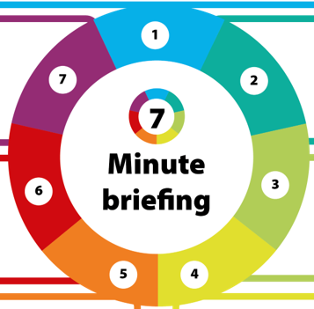
4) Learning: Personal History
Adult A’s brother provided information to the Reviewers which suggested she had experienced several triggers for self-neglect. This personal history was not known to professionals working with her and no professional appeared to have sought to understand why Adult A behaved as she did. Had this information been known to those trying to work with her, her behaviour may have been seen through a different lens and a different approach adopted.

5) Executive Functioning
Capacity was assumed even when Adult A displayed concerning behaviour i.e., non-compliance and disengagement over a long period. It did not appear from the records that consideration was given to her level of executive functioning and how this might have impacted on her capacity.
Whilst Adult A was stating to professionals that she would dress her legs herself, she clearly struggled to follow through on this which could have indicated issues with her executive functioning.

