Concise Child Practice Review – WG S71 2023

7 Minute Briefing

1) Introduction / Context
2) Background
7) Recommendations

Awareness: Increase understanding of private fostering regulations among practitioners, relevant partners, and the public.
Ensure thorough assessment and triangulation of information before approving private fostering arrangements.
Documentation: Record professional curiosity and decision-making processes clearly.
Training: Provide multi-agency training on private fostering and professional challenge.
Preparation for Learning Events: Ensure attendees are well-prepared for learning events to reduce apprehensions and provide clarity on expectations.

- Resolution of Professional Differences: Reinforce the importance of the Resolution of Professional Differences Policy.
- Police Review: Review the connection between early help and police safeguarding units.

The report is a Concise Child Practice Review commissioned by the West Glamorgan Safeguarding Board. It examined the circumstances surrounding Child A, who was subjected to abuse and neglect, leading to a review under Part 7 of The Social Services and Wellbeing Act (Wales) 2014.
Legal Context: The review was conducted in accordance with the Child Practice Review Guidance.
Circumstances: Child A sustained serious harm while under the care of private foster carers, Adult C and Adult D.
Time Period: The review covers the period from 15.03.22 to 08.05.23.
Family Composition
Child A, 4 siblings, parents (Adult A and B), foster carers (Adult C and D).
History:
The family were known to Social Services since 2011
2017: Children placed on Child Protection Register.
2022: Family re-opened to support services.
2023: Child A referred to Social Services; allegations against foster carers. Child A sexually assaulted by foster carers; foster carers arrested.

6) Professional

PracticePractice
3) Key Learning
Private Fostering Guidance:
The Children (Private Arrangements for Fostering) (Wales) Regulations 2006, provide clear directions as to the process required when assessing private fostering placements.

There was a lack of understanding among professionals regarding private fostering arrangements.
Professionals had limited experience of under taking such assessments, and a lack of familiarity in respect of the 2006 regulations
Private Fostering
Need for better understanding and assessment of private fostering arrangements.

Consent and Engagement:
Importance of valid, informed consent and effective engagement with children and families.

Interagency Working:
Robust communication and respectful challenge to support professional curiosity to be helpfully explored.
Ideally systems that facilitate the sharing of information in a timely manner.

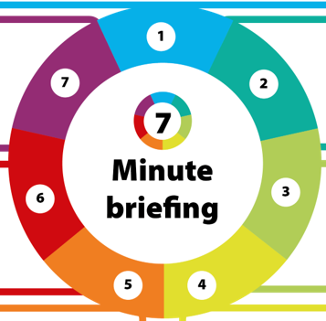
Engagement Challenges: Professionals faced difficulties engaging with Child A and her parents. Leading to missed opportunities for understanding Child A's views. This challenge, questioned the legitimacy of full parental consent as stated in the 2006 regulations.
Professional Curiosity and Respectful Challenge: Professionals noted observations that made them curious and at times uncomfortable, but these were not fully investigated or explored to evidence them.

4) Key Learning
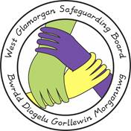
5) Key Learning
Interagency Working:
While there was evidence of good communication between agencies, information systems worked in isolation, leading to gaps in information sharing. This inhibited the sharing key information in a timely manner and frustrated a more joined up approach to multi agency working.

