7 Minute Briefing APR – WGA S23 2022 (‘David’)

7) Inter-agency and inter-disciplinary communication
An extended APR was commissioned to examine the circumstances surrounding the treatment and care of David during an extended period of imprisonment on remand. David is a man in his 20s with a history of sexual and violent offending. He had been referred to CAMHS services as an adolescent and detained in psychiatric care following criminal offences. Notwithstanding concerns regarding his disturbed and severely self-neglecting behaviour, he was found not to be experiencing severe mental illness and assessed as ‘malingering’. Professionals suggested the possible existence of dementia or brain injury, but David remained in prison for a lengthy period of time awaiting a further assessment. During this period, he experienced extreme levels of self- and environmental neglect.
- Background
2) Context

David was found repeatedly not to have a Severe Mental Illness and was remanded to HMP Parc following sexual offending behaviour while an inpatient. He exhibited highly aggressive and sexually inappropriate behaviour and severe levels of self-neglect while on remand. This coincided with the first Covid-19 lockdown, making communication with other agencies more difficult. A further assessment of David’s mental health found no psychosis but suggested possible mental impairment. A neurological assessment was recommended but did not occur, leading to David remaining in prison, exhibited extreme levels of self- and environmental neglect, in segregation for over a year.
The review found that mental health services disengaged with David after it was determined he was not experiencing a ‘SMI’. This left physical health services to attempt to source the necessary assessment without the skills or experience.
It is important that agencies continue to work in collaboration and actively engage with the MAPPA processes, when dealing with individuals who do not easily fit into a simple diagnostic category. David fell between stools as he was not considered to have a “severe mental illness”, but his extremely disturbed behaviour was beyond the expertise of physical health care professionals.
A rigid demarcation of eligibility led to withdrawal of collaboration between services.

3) Learning: Identification of mental disorder
David was not considered to have a “severe mental illness” (SMI), and this was interpreted as not being mentally ill, or alternatively not having a mental disorder. SMI is not a legal term, but mental disorder is defined in the MHA and the alternative descriptions of David’s condition clearly evidenced a mental disorder within the meaning of the MHA. The conflating of SMI and mental disorder severely impacted on the mental health care provided to David.
6) Learning: Use of the term ‘malingering’
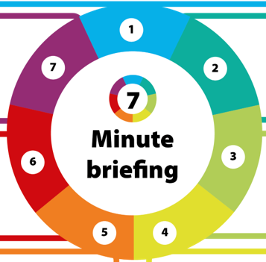
4) Learning: Mental health resources at HMP Parc
The term ‘malingering’ is described in psychiatric diagnostic manuals as feigning symptoms to obtain a goal. David was assessed as ‘malingering’, and this description followed him through much of his time in prison, undermining suggestions that he was experiencing a mental disorder.
The review suggests that the use of this term is unhelpful and risks ignoring the genuine emotional and/or psychological distress being experienced by individuals who are presenting with sometimes extremely challenging behaviour, or by labelling it as a ‘choice’ made by the person.


HMP Parc originally housed 800 prisoners but now holds twice that number. HMIP notes that the prevalence of mental ill health at HMP Parc is high, with high numbers of referrals to the mental health team. It reports that the team is under-resourced and unable to respond to need. Insufficient mental health support is available. Urgent consideration is needed to improve mental health support to HMP Parc.
5) Section 117 aftercare
David was subject to s117 aftercare following his detention on s47 in 2017. On discharge a conscious decision was taken not to provide mental health follow-up, but he was not discharged from s117. The duty was subsequently lost from the records. It is important that local authorities and health boards keep accurate records of everyone subject to s117 to ensure the duty to provide aftercare is addressed.

