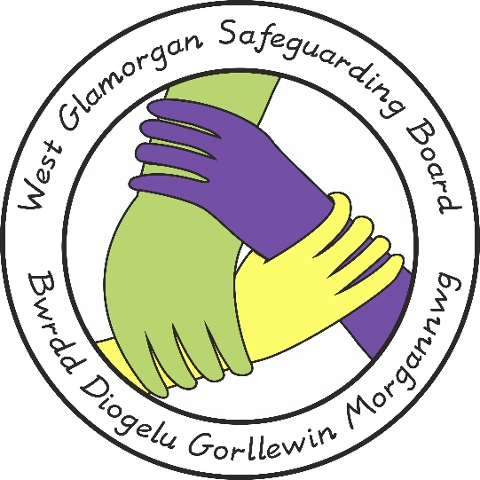

West Glamorgan Safeguarding Board

Guidance on the Intimate Body Piercing of Children

Document Author: POLICY, PRACTICE & PROCEDURE MANAGEMENT GROUP
Approved by: WGSB
Review Date: 07th of June 2023
Due for Review: 07th of June 2026

- The Public Health (Wales) Act 2017 received Royal Assent on 3 July 2017. Part 5 of the Act places a ban on the intimate piercing of children and young persons under the age of 18 this came into force on 1 February 2018.

- Wales is the first UK country to introduce such a law; it aims to protect children and young people from the potential health harms from an intimate piercing, and to avoid circumstances where children and young people are placed in a potentially vulnerable situation. It also makes it an offence to make arrangements to perform an intimate piercing on a child under the age of 18 in Wales. Any person that performs the piercing or arranges for a child to have an intimate piercing faces prosecution and an unlimited fine.

- The law applies to intimate piercings performed after 1st February 2018 and not before. The Act identifies 10 intimate body parts:

- Anus – the external opening of the bowel
- Breast - (including the nipple and areola) both male and female
- Buttock
- Natal cleft – the groove between the buttocks from just below the sacrum to the perineum
- Penis (including the foreskin)
- Perineum – the area between the anus and the scrotum in males and the anus and the vulva in females
- Pubic Mound – tissue over the pubic bone above the genitalia
- Scrotum
- Tongue
- Female genitalia – including the vulva and clitoris

- Local Authorities are the primary enforcement bodies but police may also be involved.

- If a professional becomes aware that a child has had an intimate body piercing or that, someone has arranged for it to happen (even if it did not go ahead) then children’s services within the Local Authority should be informed.

- If a professional becomes aware someone has arranged for a child to have an intimate body piercing 101 should be contacted.

